Signature Instructions
Please follow these instructions to update your email signature using the College of Business template.
- Create a new email.
- On the Insert tab, click on the drop down for “Signature” and click “Signatures…”
- You can create a new signature by clicking New, or edit the one you are currently using by first deleting the text in the Edit Signature box.
- Copy the template below and paste into the edit signature box.
PERSON NAME
Position, Department
P: (970) 491-XXXX | C: (970) 402-XXXX | My bio
XXX Rockwell Hall West,1201 Campus Delivery, Fort Collins, CO 80523
biz.colostate.edu
Facebook | Twitter | Instagram | LinkedIn

- Modify the template to include your contact information.
The “My bio” section is optional. If used, you must update the hyperlink to point to your bio page on the COB directory. To find your personal hyperlink, go to https://biz.colostate.edu/About/Directory and find your name. Click on it and copy the URL from the address bar. 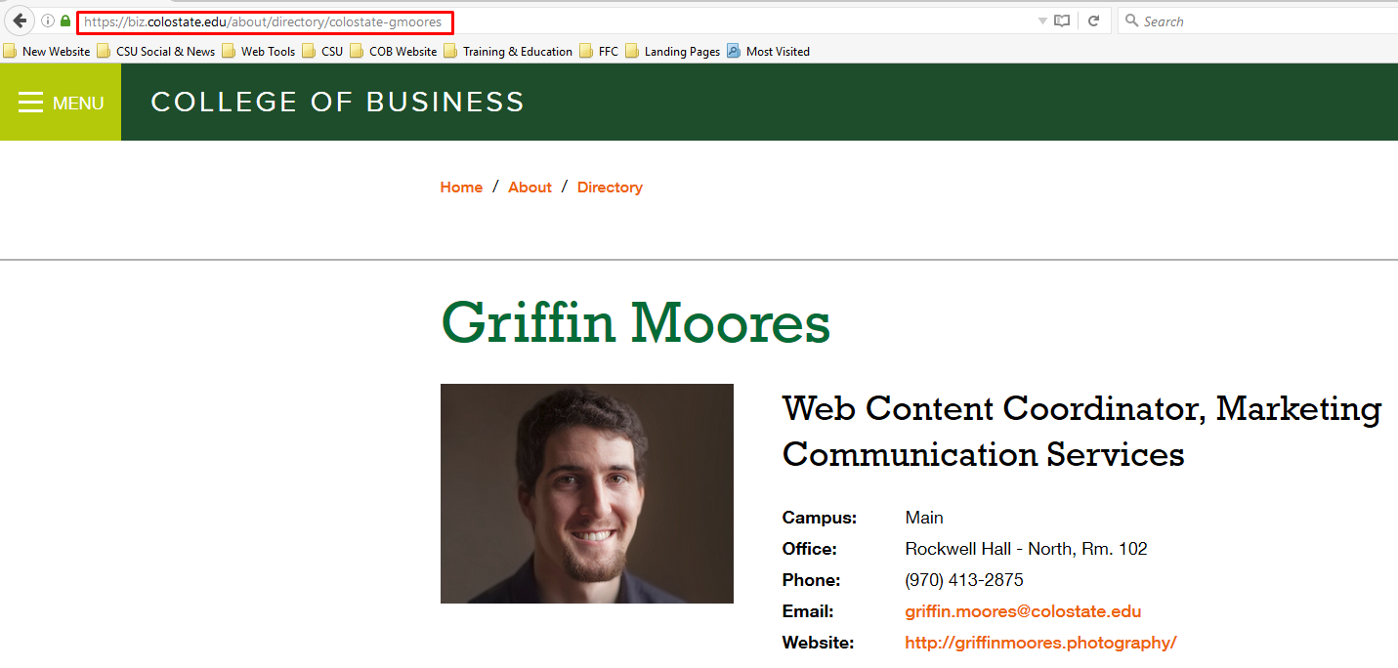Then, in your email signature, highlight the words “My bio” and right click. Choose Edit Hyperlink and then paste the new address in the address bar and click OK.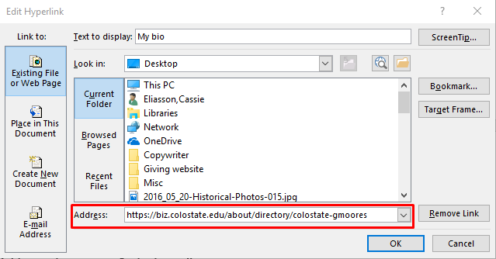
- Click OK to save your changes.

